Matthew Lam

Jason Rivkin

James Pease

Ashley Brown

Michael Carter

MIS 411 Team Project Database Operations Assignment

**Inserting Data Into Our Tables**

INSERT INTO Products (SKU, Product_Name, Product_Brand, Quantity, Item_Price) VALUES

-> (10001, 'Bread', 'Kings Hawaiian', 3, 6),

-> (10002, 'Milk', 'Horizon Organic', 2, 5),

-> (10003, 'Cereal', 'Cheerios', 4, 6),

-> (10004, 'Grapes', 'Del Monte', 12, 13),

-> (10005, 'Crackers', 'Ritz Crackers', 11, 13),

-> (10006, 'Toilet Paper', 'Charmin', 5, 10),

-> (10007, 'Olive Oil', 'California Olive Ranch', 5, 4),

-> (10008, 'Salad Dressing', 'Hidden Valley', 10, 3),

-> (10009, 'Soup', 'Progresso', 10, 3),

-> (10010, 'Pasta', 'Barilla', 3, 5);

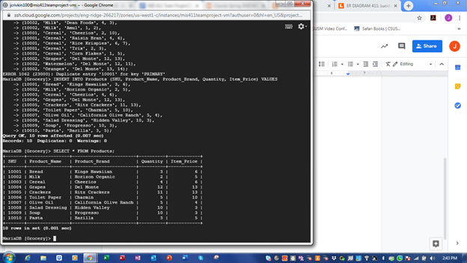

INSERT INTO Department (Department_ID, Department_Name, SKU) VALUES

-> (101, 'Bread', 10001),

-> (102, 'Milk', 10002),

-> (103, 'Cereal', 10003),

-> (104, 'Fruit', 10004),

-> (105, 'Crackers', 10005),

-> (106, 'Luxury', 10006),

-> (107, 'Oil', 10007),

-> (108, 'Dressing', 10008),

-> (109, 'Soup', 10009),

-> (110, 'Pasta', 10010);

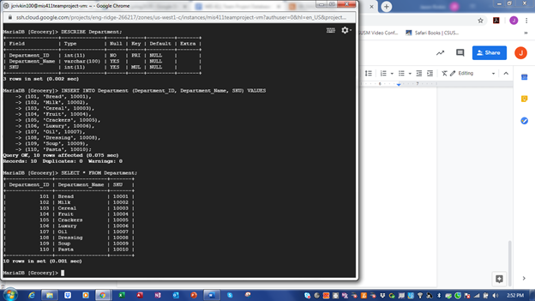

INSERT INTO Suppliers (Supplier_No, Invoice_No, SKU) VALUES (9001, 1001, 10001);

INSERT INTO Suppliers (Supplier_No, Invoice_No, SKU) VALUES (9002, 1

002, 10002);

INSERT INTO Suppliers (Supplier_No, Invoice_No, SKU) VALUES (9003, 1003, 10003);

INSERT INTO Suppliers (Supplier_No, Invoice_No, SKU) VALUES (9004, 1

004, 10004);

INSERT INTO Suppliers (Supplier_No, Invoice_No, SKU) VALUES (9005, 1

005, 10005);

INSERT INTO Suppliers (Supplier_No, Invoice_No, SKU) VALUES (9006, 1

006, 10006);

INSERT INTO Suppliers (Supplier_No, Invoice_No, SKU) VALUES (9007, 1

007, 10007);

INSERT INTO Suppliers (Supplier_No, Invoice_No, SKU) VALUES (9008, 1

008, 10008);

INSERT INTO Suppliers (Supplier_No, Invoice_No, SKU) VALUES (9009, 1

009, 10009);

INSERT INTO Suppliers (Supplier_No, Invoice_No, SKU) VALUES (9010, 1010, 10010);

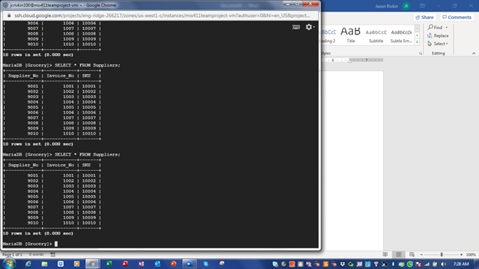

INSERT INTO Checks (Check_No, Bank_Name, Routing_No, Account_No) VALUES

-> (8001, 'Chase', 912345678, 789012345),

-> (8002, 'NavyFederal', 922345678, 799012345),

-> (8003, 'USAA', 932345678, 779012345),

-> (8004, 'USAA', 942345678, 769012345),

-> (8005, 'CitiBank', 952345678, 759012345);

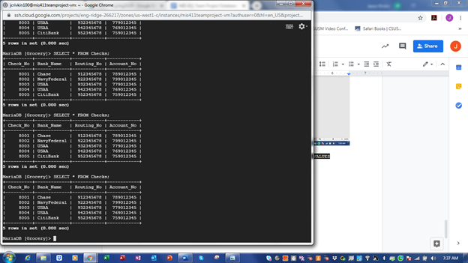

INSERT INTO Card_Information (Card_No, Card_Type, Name_On_Card) VALUES (400050004, "Visa"

, "Robert_Smith");

INSERT INTO Card_Information (Card_No, Card_Type, Name_On_Card) VALUES (400050003, "Visa", "James_Smith");

INSERT INTO Card_Information (Card_No, Card_Type, Name_On_Card) VALUES (400050002, "Visa", "John_Smith");

INSERT INTO Card_Information (Card_No, Card_Type, Name_On_Card) VALUES (400050005, "Visa", "Ashley_Smith");

INSERT INTO Card_Information (Card_No, Card_Type, Name_On_Card) VALUES (400050006, "Visa", "Steven_Smith");

INSERT INTO Card_Information (Card_No, Card_Type, Name_On_Card) VALUES (400050007, "Visa", "Chris_Smith");

INSERT INTO Card_Information (Card_No, Card_Type, Name_On_Card) VALUES (400050008, "Visa", "Roger_Smith");

INSERT INTO Card_Information (Card_No, Card_Type, Name_On_Card) VALUES (400050009, "Visa", "Jose_Smith");

INSERT INTO Card_Information (Card_No, Card_Type, Name_On_Card) VALUES (400050010, "Visa", "Matt_Smith");

INSERT INTO Card_Information (Card_No, Card_Type, Name_On_Card) VALUES (400050011, "Visa", "Jason_Smith");

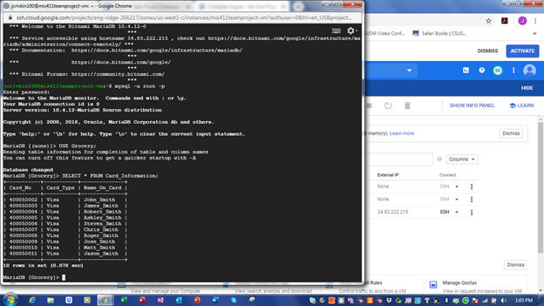

INSERT INTO Payment (Payment_No, Cash, Card_No) VALUES (7001, 210, 400050002);

INSERT INTO Payment (Payment_No, Cash, Card_No) VALUES (7002, 150, 400050003);

INSERT INTO Payment (Payment_No, Cash, Check_No) VALUES (7003, 175, 8001);

INSERT INTO Payment (Payment_No, Cash, Card_No) VALUES (7004, 35, 400050004);

INSERT INTO Payment (Payment_No, Cash, Card_No) VALUES (7005, 700, 400050005);

INSERT INTO Payment (Payment_No, Cash, Card_No) VALUES (7006, 650, 400050006);

INSERT INTO Payment (Payment_No, Cash, Card_No) VALUES (7007, 100, 400050007);

INSERT INTO Payment (Payment_No, Cash, Card_No) VALUES (7008, 50, 400050008);

INSERT INTO Payment (Payment_No, Cash, Card_No) VALUES (7009, 55, 400050009);

INSERT INTO Payment (Payment_No, Cash, Card_No) VALUES (7010, 25, 400050010);

INSERT INTO Payment (Payment_No, Cash, Check_No) VALUES (7011, 125, 8002);

INSERT INTO Payment (Payment_No, Cash, Check_No) VALUES (7012, 225, 8003);

INSERT INTO Payment (Payment_No, Cash, Check_No) VALUES (7013, 25, 8004);

INSERT INTO Payment (Payment_No, Cash, Check_No) VALUES (7014, 75, 8005);

INSERT INTO Payment (Payment_No, Cash, Card_No) VALUES (7015, 130, 400050011);

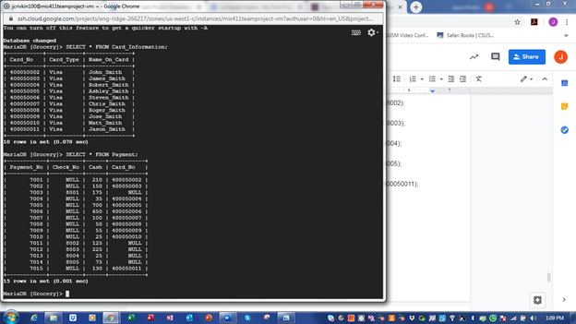

INSERT INTO Employees (Employee_No, First_Name, Last_Name, Job_Title, Department_ID) VALUES (102, "John", "Brown", "Sales", 102);

INSERT INTO Employees (Employee_No, First_Name, Last_Name, Job_Title, Department_ID) VALUES (101, "James", "Brown", "Sales", 101);

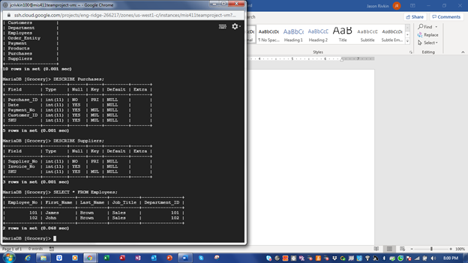

INSERT INTO Customers (Customer_ID, Customer_Name, Email, Phone, Employee_No, Payment_No) VALUES (201, "John_Smith", "john@gmail.com", 7607559999, 101, 7001);

INSERT IGNORE INTO Customers (Customer_ID, Customer_Name, Email, Phone, Employee_No, Payment_No) VALUES (202, "James_Smith", "james@gmail.com", 7607558888, 101, 7002), (211, "Robert_Smith", "robert@gmail.com", 7607557777, 101, 7004), (204, "Asley_Smith", "asley@gmail.com", 7607556666, 101, 7005), (205, "Steven_Smith", "steven@gmail.com", 7607555555, 101, 7006), (206, "Chris_Smith", "chris@gmail.com", 7607554444, 101, 7007), (207, "Roger_Smith", "roger@gmail.com", 7607553333, 101, 7008), (208, "Jose_Smith", "jose@gmail.com", 7607552222, 101, 7009), (209, "Matt_Smith", "matt@gmail.com", 7607551111, 101, 7010), (210, "Jason_Smith", "jason@gmail.com", 7607449999, 101, 7015);

INSERT IGNORE INTO Customers (Customer_ID, Customer_Name, Email, Phone, Employee_No, Payment_No) VALUES (212, "Madison_Smith", "madison@gmail.com", 7607448888, 102, 7003), (213, "Grace_Smith", "grace@gmail.com", 7607447777, 102, 7011), (214, "Riley_Smith", "riley@gmail.com", 7607446666, 102, 7012), (214, "Bethany_Smith", "bethany@gmail.com", 7607445555, 102, 7013), (215, "Sam_Smith", "same@gmail.com", 7607444444, 102, 7014);

INSERT INTO Customers (Customer_ID, Customer_Name, Email, Phone, Employee_No, Payment_No) VALUES (203, "Will_Smith", "will@gmail.com", 7607443333, 102, 7013);

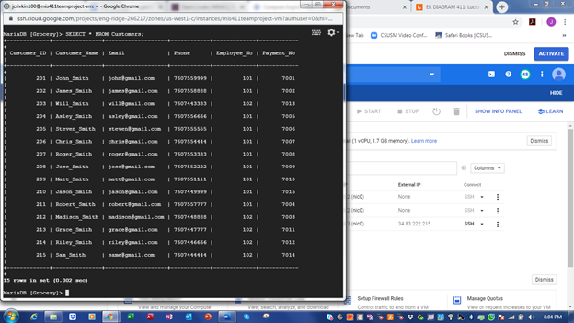

INSERT INTO Order_Entity (Order_No, Order_Date, Required_Date, Status, SKU, Quantity, Total_Bill_Amount) VALUES (9901, 042520, 052520, "Shipped", 10001, 100, 600);

INSERT IGNORE INTO Order_Entity (Order_No, Order_Date, Required_Date, Status, SKU, Quantity, Total_Bill_Amount) VALUES (9902, 042520, 052520, "Shipped", 10002, 100, 800);

INSERT IGNORE INTO Order_Entity (Order_No, Order_Date, Required_Date, Status, SKU, Quantity, Total_Bill_Amount) VALUES (9903, 042520, 052520, "Shipped", 10003, 100, 800), (9904, 042520, 052520, "Shipped", 10004, 100, 950), (9905, 042520, 052520, "Shipped", 10005, 100, 1000), (9906, 042520, 052520, "Shipped", 10006, 100, 500), (9907, 042520, 052520, "Received", 10007, 100, 600), (9908, 042520, 052520, "Received", 10008, 100, 850), (9909, 042520, 052520, "Received", 10009, 100, 200), (9910, 042520, 052520, "Received", 10010, 100, 300);

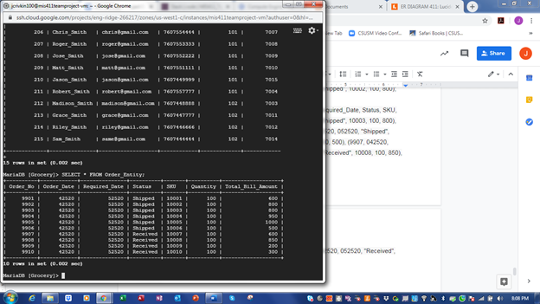

INSERT IGNORE INTO Purchases (Purchase_ID, Date, Payment_No, Customer_ID, SKU) VALUES (650, 032020, 7001, 201, 10001), (651, 032020, 7002, 202, 10002), (652, 032120, 7003, 212, 10003), (653, 032220, 7004, 211, 10004), (654, 032320, 7005, 204, 10005), (655, 032420, 7006, 205, 10006), (656, 032520, 7007, 206, 10007), (657, 032620, 7008, 207, 10008), (658, 032620, 7009, 208, 10009), (659, 032720, 7010, 209, 10010), (660, 032720, 7011, 213, 10001), (661, 032820, 7012, 214, 10002), (662, 032820, 7014, 215, 10003), (663, 032920, 7015, 210, 10004);

INSERT INTO Purchases (Purchase_ID, Date, Payment_No, Customer_ID, SKU) VALUES (664, 033020, 7013, 203, 10005);

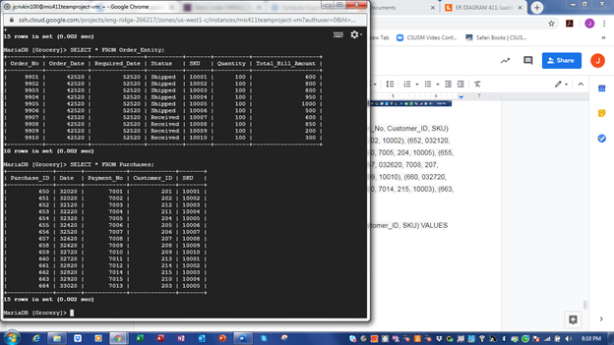

**Modifying Existing Data that We Have Entered**

UPDATE Order_Entity SET Total_Bill_Amount = 10000 WHERE Order_No = 9905;

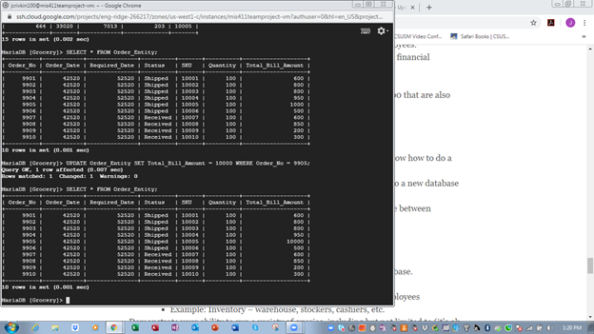

**Adding and Modifying Table Columns**

ALTER TABLE Customers ADD COLUMN State VARCHAR(2);

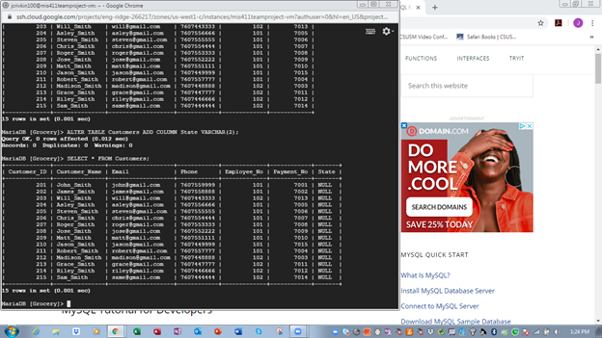

ALTER TABLE Department CHANGE COLUMN Department_ID Department_No INT;

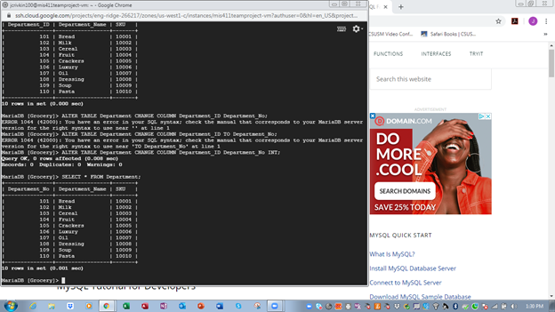

**Backing Up and Restoring Our Database**

mysqldump --user=root --password --lock-tables --databases Grocery > Grocery.sql

mysqldump --user=root --password --execute “DROP DATABASE Grocery;”

mysqldump --user=root --password < Grocery.sql

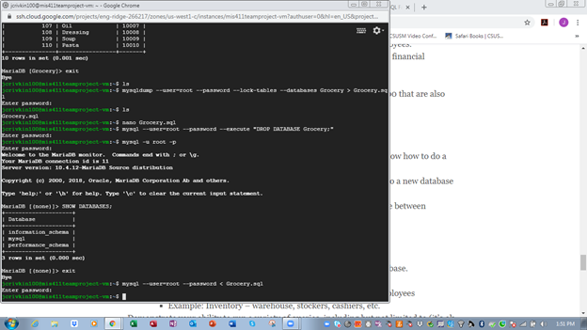

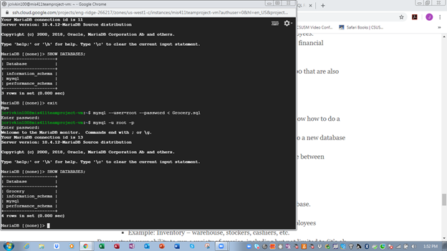

**Copying Table Structure Without the Data Into a New Database**

CREATE DATABASE Grocery2;

CREATE TABLE Grocery2.Customers_New LIKE Grocery.Customers

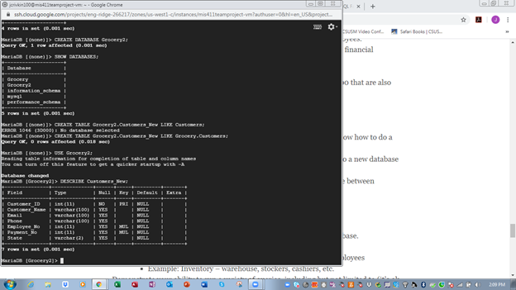

**Creating and Modifying Access Permissions**

CREATE USER ‘sora_roxas’@’localhost’;

GRANT USAGE ON Grocery.* TO ‘sora_roxas’@’localhost’;

GRANT SELECT, INSERT, UPDATE ON Grocery.* TO ‘sora_roxas’@’localhost’;

REVOKE UPDATE ON Grocery.* FROM ‘sora_roxas’@’localhost’;

SHOW GRANTS FOR ‘sora_roxas’@’localhost’;

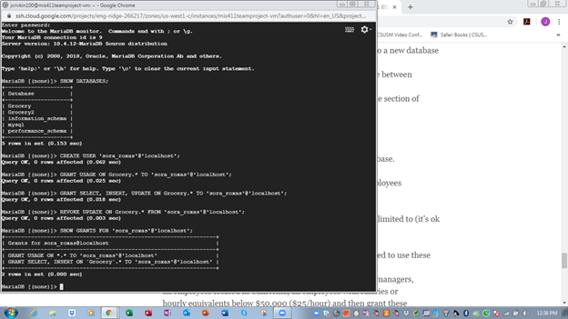

**Running a Variety of Queries**

SELECT Cash FROM Payment WHERE Cash > 200;

SELECT Payment_No, Check_No, Cash, Card_No FROM Payment WHERE Cash > 200;

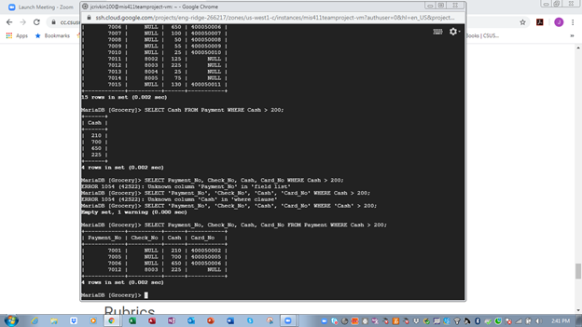

SELECT COUNT(*) FROM Card_Information WHERE Card_Type = 0;

SELECT COUNT(*) FROM Card_Information WHERE Card_Type IS NOT NULL;

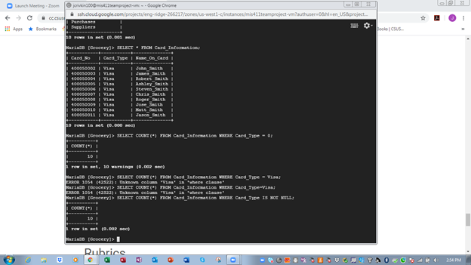

SELECT * FROM Customers WHERE Employee_No = 102;

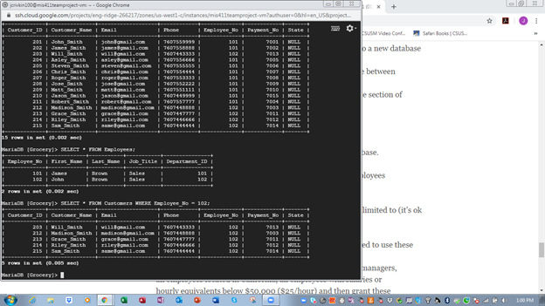

SELECT * FROM Employees WHERE First_Name = ‘John’;

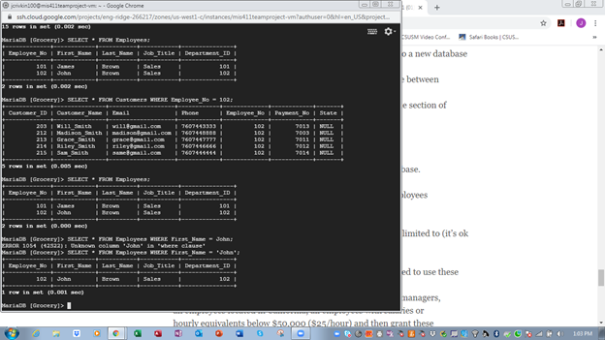

SELECT * FROM Department WHERE SKU > 10007 AND SKU < 10010;

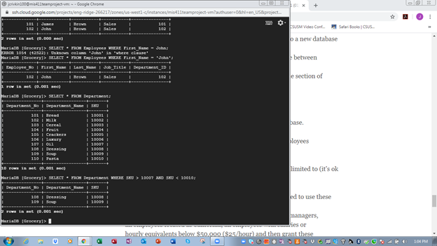

SELECT NOW ();

SELECT NOW (), CURDATE(), CURTIME();

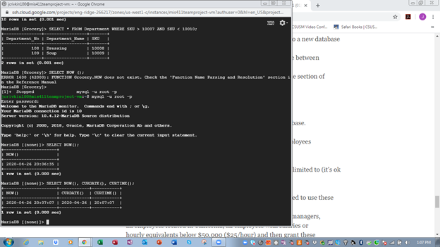

SELECT * FROM Checks WHERE Check_No > 8003 AND Bank_Name = ‘USAA’;

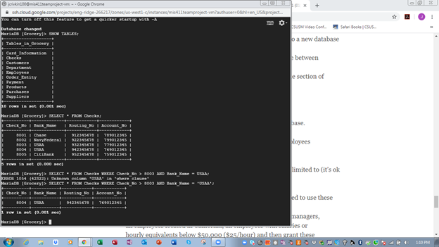

SELECT * FROM Products WHERE Quantity < 5 AND Item_Price > 3;

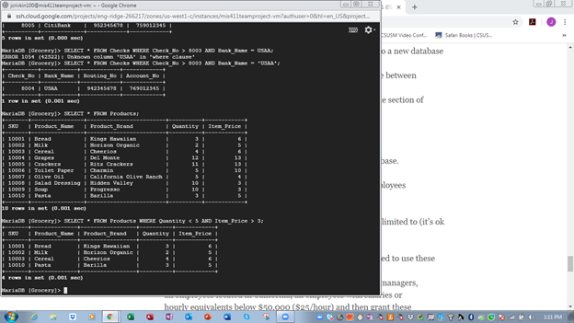

SELECT * FROM Suppliers WHERE SKU > 10003 AND Supplier_No > 9003;

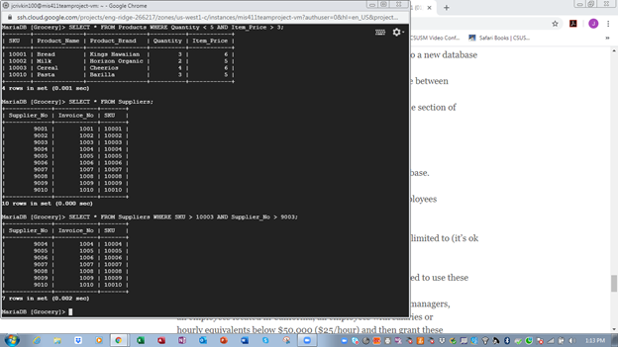

SELECT COUNT(*) FROM Suppliers GROUP BY SKU;

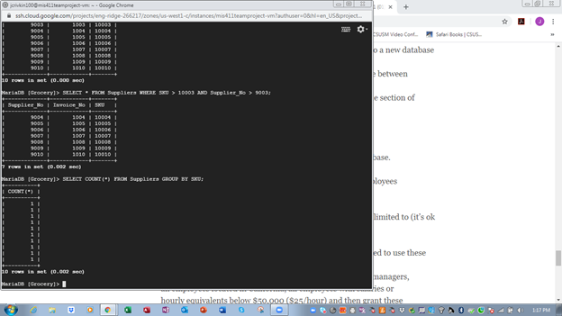

SELECT COUNT(*) FROM Payment WHERE Check_No IS NOT NULL;

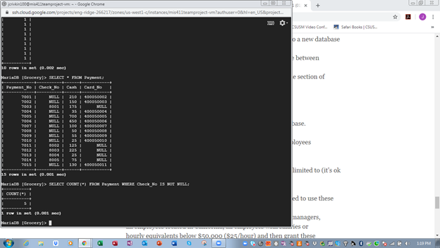

SELECT * FROM Order_Entity WHERE Status = ‘Received’;

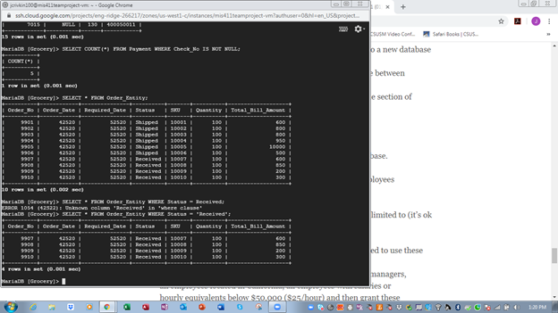

SELECT Date AS Date_of_Purchase FROM Purchases WHERE SKU= (SELECT SKU FROM Order_Entity WHERE Total_Bill_Amount= 10000);

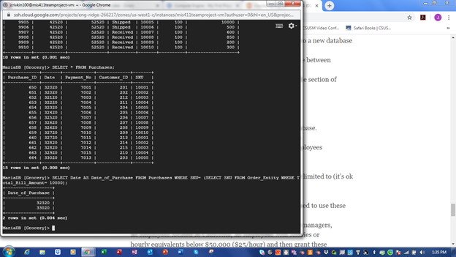

SELECT Supplier_No, Invoice_No FROM Suppliers JOIN Products WHERE Products.SKU = Suppliers.SKU;

